**NCP ASSIGNMENT**

**NESTED TABLES AND IMAGE MAP**

**RAGUL S V**

**CB.EN.U4CSE17348**

1. **NESTED TABLE:**

<!DOCTYPE html>

<html>

<head>

<title>Nested Table</title>

<style>

body{

padding:0px;

margin:0px;

}

table,tr,td{

border: 1px solid black;

border-collapse: collapse;

padding:10px;

}

</style>

</head>

<body>

<table style="width:50%;margin:auto;margin-top:100px;background-color:#E0E0E0;text-align: center;">

<tr>

<td rowspan="4" colspan="2">Contact:</td>

<td colspan="2" >Name</td>

</tr>

<tr></tr>

<tr>

<td>

<table style="width:100%;margin:auto;">

<tr>

<td>First Name</td>

<td>Last Name</td>

</tr>

<tr>

<td>Ragul</td>

<td>S V</td>

</tr>

</table> </td>

</tr>

</table> </body ></html>

**OUTPUT:**

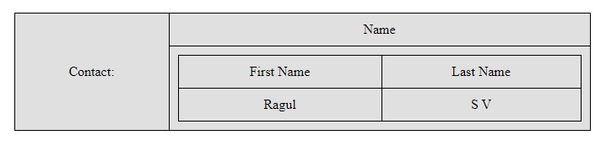

1. **IMAGE MAP**

<!DOCTYPE html>

<html>

<head>

<title>Image Map</title>

<style>

body{

padding:0px;

margin:0px;

}

</style>

</head>

<body>

<div style="margin-left:180px;margin-top:50px;">

<h3>Click on first portion to know about Mercury</h3>

<h3>Click on first portion to know about Venus</h3>

<h3>Click on first portion to know about Earth</h3>

</div>

<img src="rectangle.jpg" usemap="#rectmap" style="width:50%;height:400px;">

<map name="rectmap">

<area shape="rect1" coords="100,20,200,220" href="https://en.wikipedia.org/wiki/Mercury_(planet)">

<area shape="rect1" coords="200,20,300,220" href="https://en.wikipedia.org/wiki/Venus">

<area shape="rect1" coords="300,20,400,220" href="https://en.wikipedia.org/wiki/Earth">

</map>

<div>

</body>

</html>

**OUTPUT:**

